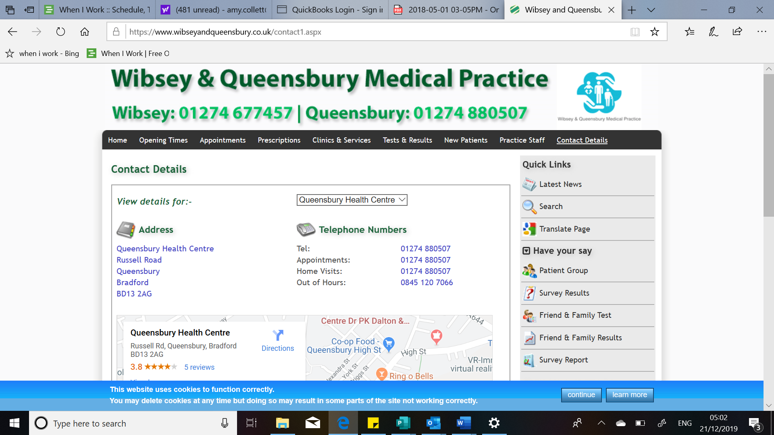****

**Wibsey & Queensbury**

**Patient Participation Group**

**Would you like to help us in the way we deliver our services?**

**Would you want to be**

**‘a voice’**

**for our patients**

**We Hold friendly informal meetings every 6 weeks later afternoons, either at Wibsey or Queensbury –**

**All Welcome.**

**Please ask the receptionist for further detail if you would like to attend.**